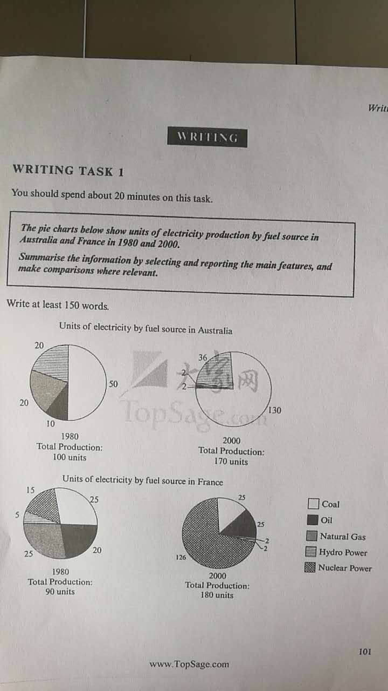

The graph illustrates units of electricity produced by fuel in 1980 and 2000 in Australia and France.

The top two charts show that there is a significantly rise of coal used between 1980 and 2000 from 50 units to 130 units. At the same time, the use of oil and natural gas as an energy source also made a dramatic drop to 2 units. Meanwhile, there is a slightly increase on hydro power from 20 units to 36 units. As for the whole country, Australia managed to make a total production grow from 100 units to 170 units.

The construct of France’s electricity use is more complex. The use of nuclear power grew rapidly from 15 units to 126 units, while both hydro power and natural gas had been decreased to 2 units. There is no change on the use of coal at all. However, oil was used more, it slightly increased from 20 to 25. The total production had doubled in France in 2000.

Compare two countries, there is no strong connections between their electricity production.